QUADMARTS Workshop, Caltech, Nov. 9-11, 2026
 |  | 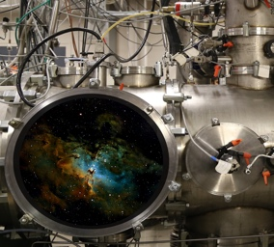 | 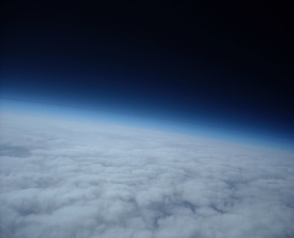 | 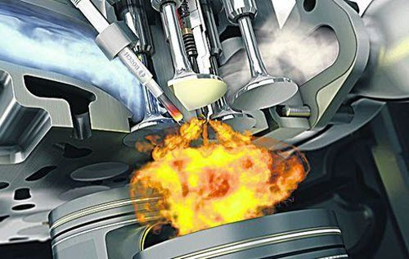
 |  | KECK INSTITUTE FOR SPACE SCIENCE
Monday November 9
7h30 | Breakfast
8h30 | Welcome
Session 1 |  |  |  |  | Session chair:
8h35(30’+10’)
9h15 (15’+5’)
9h35 (15’+5’)
9h55 (50’) | Coffee break + posters
Session 2 |  |  |  |  | Session chair:
10h45 (30’+10’)
11h25 (15’+5’)
11h45 (15’+5’)
12h05-13h30 | Lunch
Session 3 |  |  |  |  | Session chair:
13h30 (30’+10’)
14h10 (15’+5’)
14h30 (15’+5’)
14h50 (50’) | Coffee break + posters
Session 4 |  |  |  |  | Session chair:
15h40 (30’+10’)
16h20 (15’+5’)
16h40 (15’+5’)
17h30 – 19h30 | Young Researcher’s meeting

Tuesday November 10
7h30 | Breakfast
Session 5 |  | Session chair:
8h30(30’+10’)
9h10 (15’+5’)
9h30 (15’+5’)
9h50 (50’) | Coffee break + posters
Session 6 |  | Session chair:
10h40 (30’+10’)
11h20 (15’+5’)
11h40 (15’+5’)
12h00-13h30 | Lunch
Session 7 |  | Session chair:
13h30 (30’+10’)
14h10 (15’+5’)
14h30 (15’+5’)
14h50 (50’) | Coffee break + posters
Session 8 |  | Session chair:
15h40 (30’+10’)
16h20 (15’+5’)
16h40 (15’+5’)
18h00 – 20h00 | Banquet

Wednesday November 11
8h00 |  | Breakfast
9h30 – 13h00 |  | Huntington Gardens excursion
Session 9 |  |  | Session chair:
13h30 (30’+10’)
14h10 (15’+5’)
14h30 (15’+5’)
14h50 (20’) | Coffee Break
Session 10 |  |  | Session chair:
15h10 (30’+10’)
15h50 (15’+5’)
16h10 (15’+5’)
16h30 (∞) |  | Concluding remarks and perspectives

